mbruner3_assign2

Mark Bruner

10/27/2020

rm(list=ls())

library(tidyverse)

## ── Attaching packages ─────────────────────────────────────── tidyverse 1.3.0 ──

## ✓ ggplot2 3.3.2 ✓ purrr 0.3.4  
## ✓ tibble 3.0.4 ✓ dplyr 1.0.2  
## ✓ tidyr 1.1.2 ✓ stringr 1.4.0  
## ✓ readr 1.4.0 ✓ forcats 0.5.0

## ── Conflicts ────────────────────────────────────────── tidyverse_conflicts() ──  
## x dplyr::filter() masks stats::filter()  
## x dplyr::lag() masks stats::lag()

library(colorspace)

## **QUESTION 1**

### **part a**

set.seed(2017)  
X=runif(100)*10  
Y=X*4+3.45  
Y=rnorm(100)*0.29*Y+Y  
  
X <- as.data.frame(X)  
Y <- as.data.frame(Y)  
table <- cbind(X, Y)  
  
table %>%   
ggplot(mapping = aes(x = X, y = Y)) +  
 geom_point(colour = "firebrick3") +  
 labs(title = "Scatter Plot of X & Y")

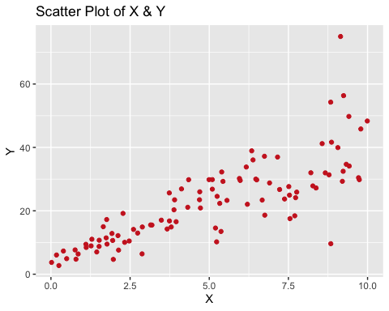

Yes we will be able to fit a linear model to this data. The reason is, in general, as x increases so does y. Therefore, that implies that there is a relationship between x and y making it possible to create a linear mapping function that fits the data.

### **part b**

lin_reg <- lm(Y~ X, table)  
lin_reg

##   
## Call:  
## lm(formula = Y ~ X, data = table)  
##   
## Coefficients:  
## (Intercept) X   
## 4.465 3.611

The model equation that explains y to x: **y = 3.611x + 4.465**. **For accuracy of the model see part c.**

## **part c:** **note**: includes accuracy from part b

summary(lin_reg)

##   
## Call:  
## lm(formula = Y ~ X, data = table)  
##   
## Residuals:  
## Min 1Q Median 3Q Max   
## -26.755 -3.846 -0.387 4.318 37.503   
##   
## Coefficients:  
## Estimate Std. Error t value Pr(>|t|)   
## (Intercept) 4.4655 1.5537 2.874 0.00497 **   
## X 3.6108 0.2666 13.542 < 2e-16 ***  
## ---  
## Signif. codes: 0 '***' 0.001 '**' 0.01 '*' 0.05 '.' 0.1 ' ' 1  
##   
## Residual standard error: 7.756 on 98 degrees of freedom  
## Multiple R-squared: 0.6517, Adjusted R-squared: 0.6482   
## F-statistic: 183.4 on 1 and 98 DF, p-value: < 2.2e-16

The r^2 is 65%, meaning that 65% of the variability of Y is captured by it captured by X.

## EXTRA INVESTIGATIONS/EXPLORATION

I decided to use some of the concepts in class to further explore and practice. You can skip the next couple of graphs as they do not pertain to this assignment.

lin_reg %>%   
ggplot(mapping = aes(x = lin_reg$residuals)) +  
 geom_histogram(colour = "lightsteelblue4", fill = "lightsteelblue", binwidth = 2) +  
 labs(title = "Histogram of the Linear Regression Residuals") +  
 xlab("Residuals") +  
 theme(plot.title = element_text(face = "bold", hjust = .5))

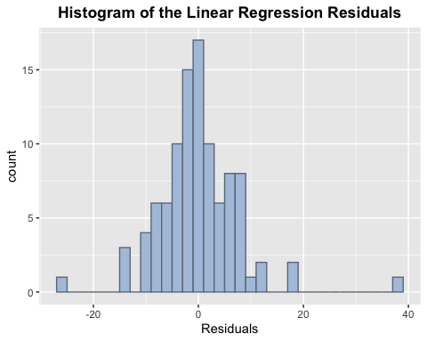

The above graph shows a fairly normal residual distribution with maybe a couple of outliers.

table %>%   
ggplot(mapping = aes(x = X, y = Y), ) +  
 geom_point(colour = "dodgerblue") +  
 stat_smooth(method = "lm", colour = "firebrick2", se = FALSE) +  
 labs(title = "Scatter Plot and Linear Regression Line", subtitle = "Linear Regression Model Equation: y = 3.611x + 4.465") +  
 theme(plot.title = element_text(face = "bold", hjust = .5), plot.subtitle = element_text(face = "italic", hjust = .5))

## `geom_smooth()` using formula 'y ~ x'

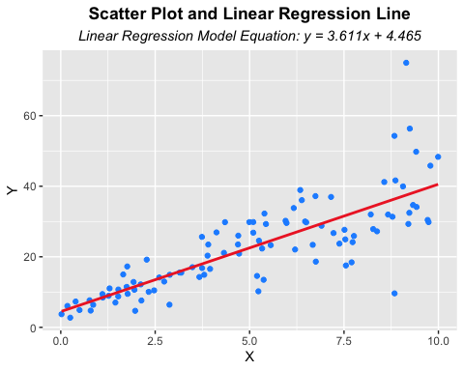

## **QUESTION 2**

### **part a**

**HP as a function of Weight**

cars <- mtcars  
  
cars %>%   
ggplot(mapping = aes(x = wt, y = hp, colour = cyl)) +  
 geom_point(size = 2) +   
 scale_color_gradient(low = "steelblue", high = "firebrick1")

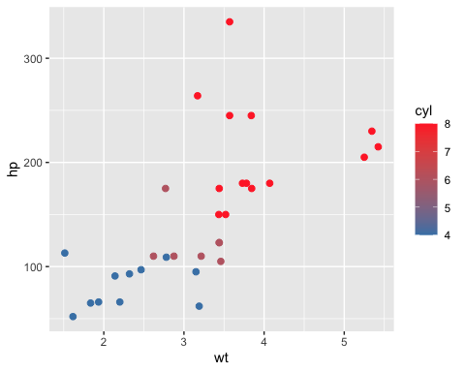

My initial observation on the above graph is that the two are not strongly related. As x increases y increase to about x = 3 there seems to be a relationship but after 3 the points become more scattered and more spread out.

**Linear regression formula for hp ~ wt**

lin_reg <- lm(hp ~ wt, cars)  
lin_reg

##   
## Call:  
## lm(formula = hp ~ wt, data = cars)  
##   
## Coefficients:  
## (Intercept) wt   
## -1.821 46.160

**R^2**

summary(lin_reg)

##   
## Call:  
## lm(formula = hp ~ wt, data = cars)  
##   
## Residuals:  
## Min 1Q Median 3Q Max   
## -83.430 -33.596 -13.587 7.913 172.030   
##   
## Coefficients:  
## Estimate Std. Error t value Pr(>|t|)   
## (Intercept) -1.821 32.325 -0.056 0.955   
## wt 46.160 9.625 4.796 4.15e-05 ***  
## ---  
## Signif. codes: 0 '***' 0.001 '**' 0.01 '*' 0.05 '.' 0.1 ' ' 1  
##   
## Residual standard error: 52.44 on 30 degrees of freedom  
## Multiple R-squared: 0.4339, Adjusted R-squared: 0.4151   
## F-statistic: 23 on 1 and 30 DF, p-value: 4.146e-05

**HP as a function of MPG**

cars %>%   
ggplot(mapping = aes(x = mpg, y = hp, colour = cyl)) +  
 geom_point() +  
 labs(title = "Scatter Plot of mtcars MPG and WT") +   
 theme(plot.title = element_text(face = "bold", hjust = .5)) +   
 scale_color_gradient(low = "steelblue", high = "firebrick1")

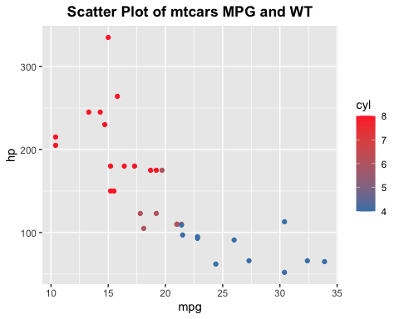

There seems to be a stronger correlation between hp ~ mpg due to as x increases y decreases, generally.

lin_reg <- lm(hp ~ mpg, cars)  
lin_reg

##   
## Call:  
## lm(formula = hp ~ mpg, data = cars)  
##   
## Coefficients:  
## (Intercept) mpg   
## 324.08 -8.83

summary(lin_reg)

##   
## Call:  
## lm(formula = hp ~ mpg, data = cars)  
##   
## Residuals:  
## Min 1Q Median 3Q Max   
## -59.26 -28.93 -13.45 25.65 143.36   
##   
## Coefficients:  
## Estimate Std. Error t value Pr(>|t|)   
## (Intercept) 324.08 27.43 11.813 8.25e-13 ***  
## mpg -8.83 1.31 -6.742 1.79e-07 ***  
## ---  
## Signif. codes: 0 '***' 0.001 '**' 0.01 '*' 0.05 '.' 0.1 ' ' 1  
##   
## Residual standard error: 43.95 on 30 degrees of freedom  
## Multiple R-squared: 0.6024, Adjusted R-squared: 0.5892   
## F-statistic: 45.46 on 1 and 30 DF, p-value: 1.788e-07

The answer is that MPG is a better predictor for HP than weight. 60% of the variance in the HP can be explained by the MPG of a car. Comparatively, only 43% of the variance in HP can be explained by the weight of a car.

### **part b**

lin_reg <- lm(hp ~ cyl + mpg, cars)  
lin_reg

##   
## Call:  
## lm(formula = hp ~ cyl + mpg, data = cars)  
##   
## Coefficients:  
## (Intercept) cyl mpg   
## 54.067 23.979 -2.775

y = 23.979x1 - 2.775x2 + 54.067

summary(lin_reg)

##   
## Call:  
## lm(formula = hp ~ cyl + mpg, data = cars)  
##   
## Residuals:  
## Min 1Q Median 3Q Max   
## -53.72 -22.18 -10.13 14.47 130.73   
##   
## Coefficients:  
## Estimate Std. Error t value Pr(>|t|)   
## (Intercept) 54.067 86.093 0.628 0.53492   
## cyl 23.979 7.346 3.264 0.00281 **  
## mpg -2.775 2.177 -1.275 0.21253   
## ---  
## Signif. codes: 0 '***' 0.001 '**' 0.01 '*' 0.05 '.' 0.1 ' ' 1  
##   
## Residual standard error: 38.22 on 29 degrees of freedom  
## Multiple R-squared: 0.7093, Adjusted R-squared: 0.6892   
## F-statistic: 35.37 on 2 and 29 DF, p-value: 1.663e-08

71% of the variance in HP can be explained by the number of cylinders and mpg of a car. Adding cylinders as a variable increased the predictive power of this model by ~10%. I would say that is an improvement!

23.979*4 - 2.775*22 + 54.067

## [1] 88.933

A car with 4 cylinders and 22 MPG will have about 89 HP.

## **QUESTION 3**

library(mlbench)  
data(BostonHousing)

BostonHousing %>%   
 select(medv, crim, zn, ptratio, chas) -> bos_median  
  
lm(medv ~., data = bos_median) -> bos_reg  
bos_reg

##   
## Call:  
## lm(formula = medv ~ ., data = bos_median)  
##   
## Coefficients:  
## (Intercept) crim zn ptratio chas1   
## 49.91868 -0.26018 0.07073 -1.49367 4.58393

summary(bos_reg)

##   
## Call:  
## lm(formula = medv ~ ., data = bos_median)  
##   
## Residuals:  
## Min 1Q Median 3Q Max   
## -18.282 -4.505 -0.986 2.650 32.656   
##   
## Coefficients:  
## Estimate Std. Error t value Pr(>|t|)   
## (Intercept) 49.91868 3.23497 15.431 < 2e-16 ***  
## crim -0.26018 0.04015 -6.480 2.20e-10 ***  
## zn 0.07073 0.01548 4.570 6.14e-06 ***  
## ptratio -1.49367 0.17144 -8.712 < 2e-16 ***  
## chas1 4.58393 1.31108 3.496 0.000514 ***  
## ---  
## Signif. codes: 0 '***' 0.001 '**' 0.01 '*' 0.05 '.' 0.1 ' ' 1  
##   
## Residual standard error: 7.388 on 501 degrees of freedom  
## Multiple R-squared: 0.3599, Adjusted R-squared: 0.3547   
## F-statistic: 70.41 on 4 and 501 DF, p-value: < 2.2e-16

I would say probably not based on the r-squared for the model, which only 36% of the variance in the median house price is accounted for by the crime, zoning, teacher-student ratio, and the Chas River. All of the variables are statistically significant at significant levels at 0!

** part b.I**

The house that bounds the Chas River would be $4,580 more expensive than the house that does not bound the Chas River.

** part b.II**

-1.4937*15

## [1] -22.4055

-1.4937*18

## [1] -26.8866

-1.4937*15 - -1.4937*18

## [1] 4.4811

The house that resides in the neighborhood where the stud/teacher ratio is lower (15:1) would be 4.48 (thousand dollars) more expensive than the one that has 18:1 student/teacher.

**part c**

summary(lm(medv ~., data = bos_median))

##   
## Call:  
## lm(formula = medv ~ ., data = bos_median)  
##   
## Residuals:  
## Min 1Q Median 3Q Max   
## -18.282 -4.505 -0.986 2.650 32.656   
##   
## Coefficients:  
## Estimate Std. Error t value Pr(>|t|)   
## (Intercept) 49.91868 3.23497 15.431 < 2e-16 ***  
## crim -0.26018 0.04015 -6.480 2.20e-10 ***  
## zn 0.07073 0.01548 4.570 6.14e-06 ***  
## ptratio -1.49367 0.17144 -8.712 < 2e-16 ***  
## chas1 4.58393 1.31108 3.496 0.000514 ***  
## ---  
## Signif. codes: 0 '***' 0.001 '**' 0.01 '*' 0.05 '.' 0.1 ' ' 1  
##   
## Residual standard error: 7.388 on 501 degrees of freedom  
## Multiple R-squared: 0.3599, Adjusted R-squared: 0.3547   
## F-statistic: 70.41 on 4 and 501 DF, p-value: < 2.2e-16

Crime, zone, teacher/student rati, and chas river are statiscally significant at a significance level at 0 (***).

anova(lm(medv ~., data = bos_median))

## Analysis of Variance Table  
##   
## Response: medv  
## Df Sum Sq Mean Sq F value Pr(>F)   
## crim 1 6440.8 6440.8 118.007 < 2.2e-16 ***  
## zn 1 3554.3 3554.3 65.122 5.253e-15 ***  
## ptratio 1 4709.5 4709.5 86.287 < 2.2e-16 ***  
## chas 1 667.2 667.2 12.224 0.0005137 ***  
## Residuals 501 27344.5 54.6   
## ---  
## Signif. codes: 0 '***' 0.001 '**' 0.01 '*' 0.05 '.' 0.1 ' ' 1

The order of importance of these variables is as follow (most importance to least): 1) Crime rate  
2) Student:Teacher 3) Zone 4) Chas River